**Submission to the Select Committee for Energy Security and Net Zero - Inquiry**

**From: Offton & Willisham Pylons Group**

**Authors: Harry & Jane Lushington  
 October 2023**

# The Challenge We Face

This document is put together to highlight the very wrongs that are happening and enable the Select Committee to conclude that a viable offshore grid is the sensible way forward.

It describes:

* + An introduction based on National Grid Proposals
  + National Grid Process
  + Their favoured solution
  + Why it is wrong
  + The opportunity to fix things
  + National Grids own cost benefit analysis against its favoured solution.

The path we need your help with to get on track to NET ZERO.

# Introduction

Considerations for power requirements for the future cover:

* + New power sources including offshore wind
  + East Anglia expected to use only max 8% power from North Sea wind, the majority going to London *
  + Existing high-voltage pylons set up 40/50 years ago for distribution to East Anglia

* Source: National Grid ET’s most recent consultation documentation

** At a consultation in Southwold on 15/9/23 National Grid members stated that offshore was expensive and inefficient due to marine wrecks and bird sanctuaries. Next door was a presentation for Sealink, a cable running from Sizewell to Kent through the same waters

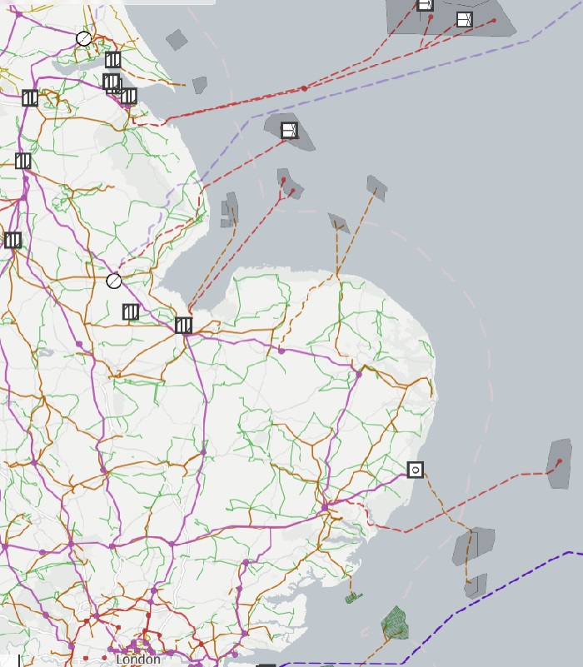

Hornsea 2 & 1

Dudgeon

Tritton Knoll

Sheringham Shoal

Race Bank

Lincs

East Anglia 1

Greater Gabbard

Gunfleet Sands

London Array

Humber Gateway

Westermost Rough

WALPOLE

NECTON

NORWICH MAIN

BRAMFORD

BRADWELL

LAWFORD

National Grid has been running consultations where the solution is prescribed as more pylons

* + There is something Orwellian about the approach **
  + Out-dated, expensive, slow (timelines 5-7 years) and environmentally damaging.

Long term damage will be created to people (local and national) through planning blight, a long construction process and ineffective implementation.

Please ensure an Offshore Grid is put on the Statutory Consultation for East Anglia.

# National Grid Process

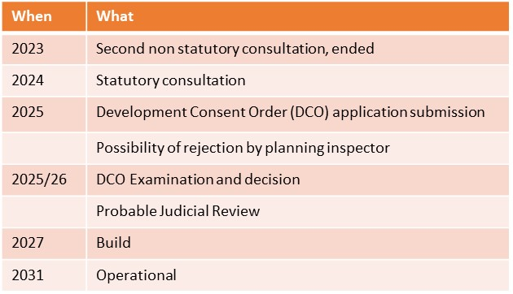Two non statutory consultations have been run by NG. These have been piecemeal and simplistic, with ‘non-factual’ arguments presented. Treasury Green book and Holford rules have not been followed. A statutory consultation can only select the options presented. The solution by National Grid has been years in development and is willfully mis-representing facts.

The process to date is an “HS2-type” approach – pre-determined, groupthink, and outdated governance.

# National Grid Favoured Solution

Pylons to be used except for AONB * ***. Costs and timescales – vague **. Arbitrary decision to push this through to be seen to do something. Not actually ‘green’. Slow and costly solution (see timeline). Not future-proofed *. Ongoing uncertainty.

Is this a cover-up for decisions already made by National Grid due to a piecemeal approach?

* Meeting National Grid Copdock consultation 19/7/23, Pylons recommended as this was stated as “government policy”.

** NG is unclear what power due from offshore, and unable to state whether 1 set of pylons or more required.

*** AONB to have 100m wide destruction corridor (3 lane motorway), and cables heat the soil thus scar the landscape.

# Government Opportunity for an Holistic UK Solution

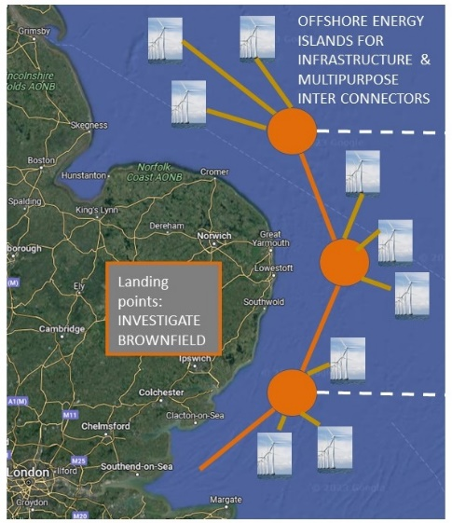Flexible integrated grid

* + Future proof
  + Fast
  + Simple *
  + Cost Effective
  + Proven Technology **

An holistic solution provides both energy security and is green. We are an island nation, and should be using this to our advantage.

* From a meeting with Dr Dan Poulter MP on 15/9/23 a constituent had just come back from laying cable offshore in Brazil (in just weeks) and had moved to surveying in the North Sea.

** Current operational and future approved offshore networks:

* + Drax to Peterhead
  + Lincs to Denmark
  + Sizewell to Kent.

# NG Own Recognition of Offshore Grid

National Grids Own Cost Benefit Analysis is as per chart below. This shows Integrated (ie Offshore) verses Counterfactual (ie Status quo, piecemeal, pylons)

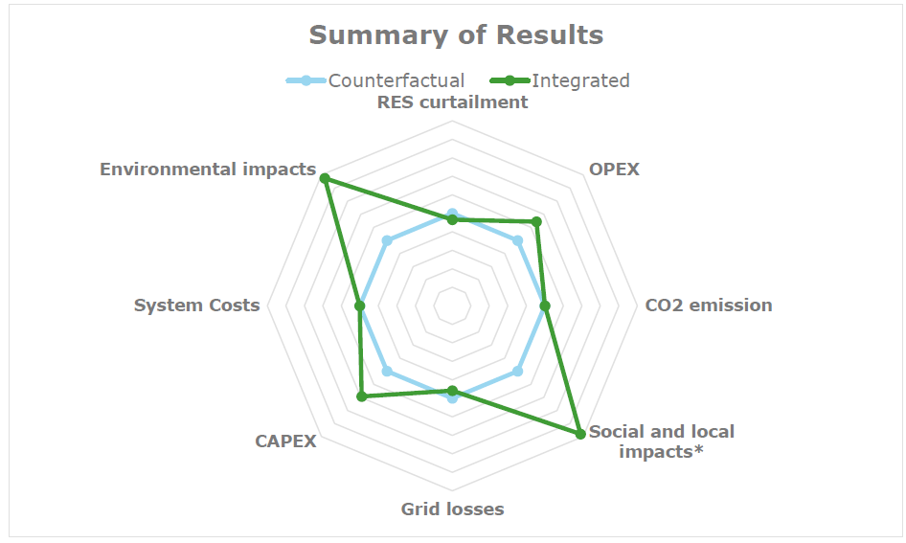

“As a result of our analysis it is evident that Integrated design scores better in Environmental Impacts, Social and Local impacts, CAPEX and OPEX. The Integrated also scores better on all qualitative KPIs that are related to the Security of electricity supply. For the other KPIs we did not observe notable differences between the Integrated and the Counterfactual, therefore at this stage concluding that the Integrated approach is more advantageous overall” *

* Source: National Grid ESO 2020.

This demonstrates both the financial benefit and the socio-environmental benefits of offshore. Offshore also provides for a faster and more flexible solution. So Why is National Grid unable to

* + Read its own reports
  + Read the Treasury Green book (other than introduce an alternative that it dismisses)
  + Follow the Holford rules?

# Opportunity to Present to You

We ask for the opportunity to present to you to highlight the opportunities and threats from National Grid. Its approach will affect 1000s of ordinary folk. We wish to provide a view from the ‘coal face’, presenting facts not fiction.

Surveying Pylon sites in Offton 4/10/23

# Now is the Time to Challenge Preconceived and Predetermined Proposals

Help the UK achieve a long-term stable green power infrastructure.

**YES to the GREEN alternative**

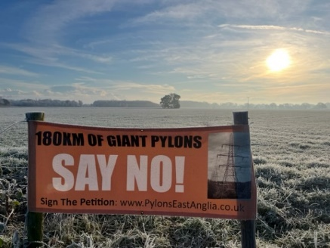SAY YES TO OFFSHORE

SAY YES TO FASTER, CHEAPER, BETTER (AND GREENER) INFRASTRUCTURE

(And no to Biggliest Pylons)