Offton and Willisham Parish Council
Clerk to the Council: Miss T Davis
16 Bramley Place
Debenahm
STOWMARKET
IP14 6FG
Tel: 07425 672631

14th Oct 2025

I hereby give notice that an extraordinary meeting of Offton & Willisham Parish Council has been called and will be held at the Offton and Willisham Village Hall on Thursday 30th October 2025 commencing at 7.30pm. The Press and the Public are invited to attend, Councillors are summoned to attend.
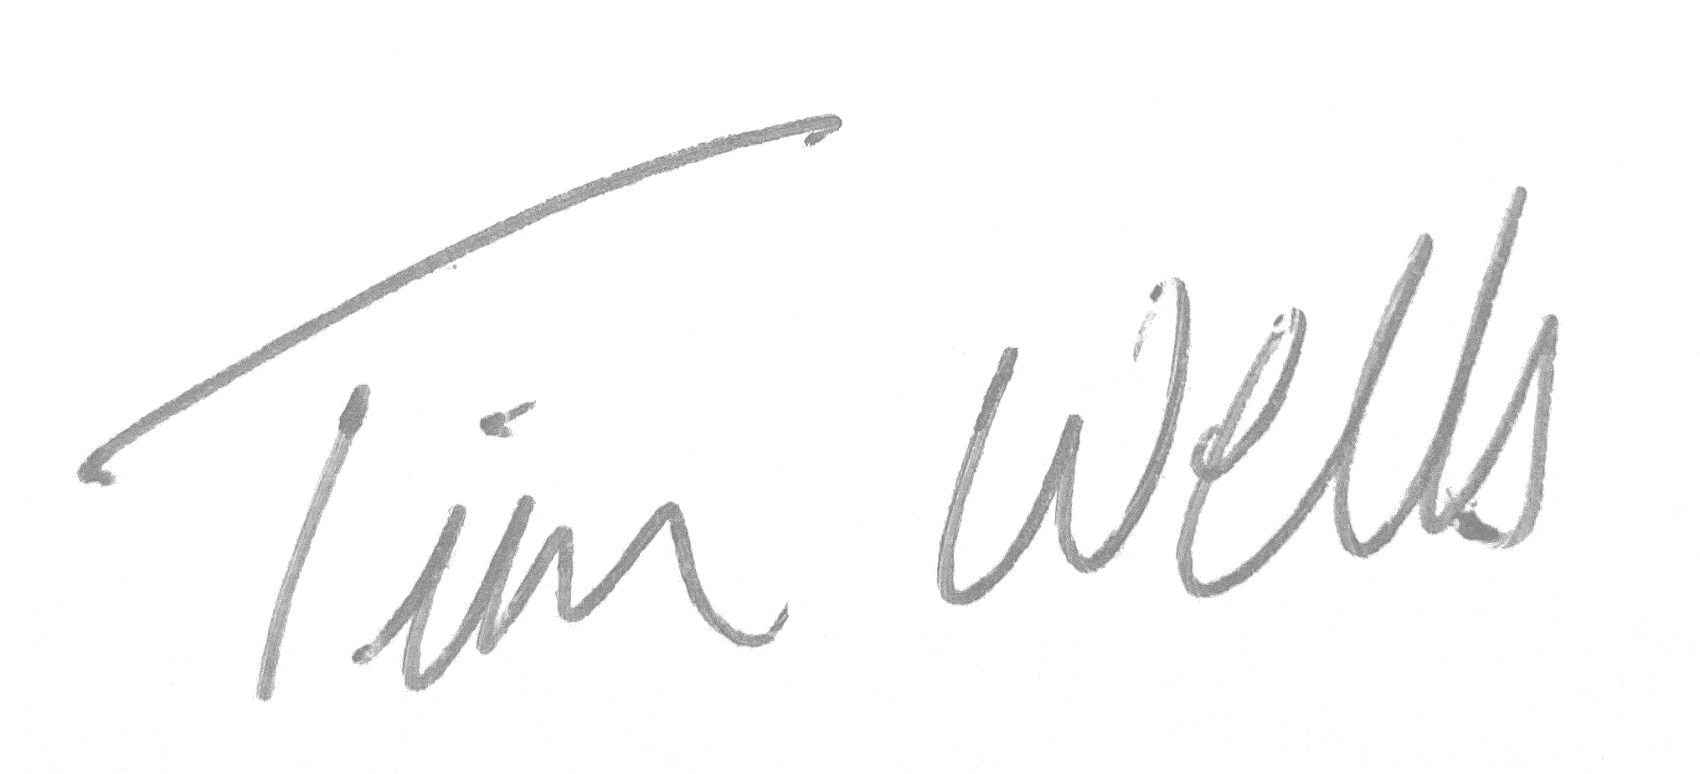 Chair of the Parish Council.

The Parish Council, members of the public and the press may record, film, photograph or broadcast this meeting when the public and the press are not lawfully excluded. Any member of the public who attends a meeting and wishes to record, film, and photograph or broadcast the meeting should advise the Parish Clerk.
Public questions during a remote meeting: Questions can be forwarded to the Clerk prior to the meeting via email (as above) or given in person during item 3 - Public Participation. Members of the public may not take part in the Parish Council meeting itself, unless with the permission of the Chairman to do so.

AGENDA

- Meeting administration
- Chair to welcome everyone and open the meeting
- Minute Silence in Remembrance
- To note Apologies for absence
- To receive Declarations of interest on agenda items
- To Approve the draft minutes of 19th August 2025 and for the Chairman to sign as a true record
- Matters arising from 19th August minutes
- Public Participation Session (To hear reports from the County Councillor, District Councillor and Comments from the Public)
- Finance
- Current Bank Balances as at 30th Sept 2025:-
Current Account = £6,375.46
Savings Account = £16,542.46
Barclays residual = £00.04
- To confirm payments received since 19th August 2025 meeting
i.MSDC Precept - £5,900.50
ii.Bank Interest on Savings A/C - £93.29
- To confirm payments made since 19th August 2025 meeting
    - Clerk Wages Sept - £436.48
    - SALC Payroll - £54.00
    - Suffolk Cloud (Hosting and Support ) - £120.00
c) Payments for authorisation (Resolution required)
i. Clerk Office & Mileage - £88.70
Ii. Clerk Wages Oct - £436.48
d) To review and approve the 2nd Quarter Accounts - Cllr Cox
- To cancel the next meeting, currently Tuesday 4th November 2025 and provide a new date if needed

