**Offton and Willisham Parish Council**

Clerk to the Council: Miss T Davis

16 Bramley Place

Debenahm

STOWMARKET

IP14 6FG

Tel: 07425 672631

14th Aug 2025

I hereby give notice that an extraordinary meeting of Offton & Willisham Parish Council has been called and will be held at the Offton and Willisham Village Hall on Tuesday 19th July 2025 commencing at 7.30pm. The Press and the Public are invited to attend, Councillors are summoned to attend.

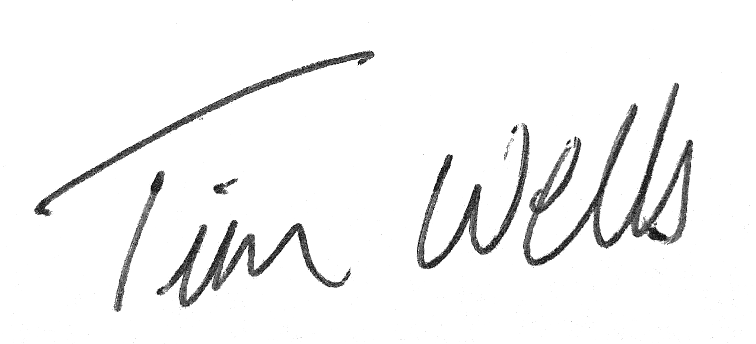 Chair of the Parish Council.

The Parish Council, members of the public and the press may record, film, photograph or broadcast this meeting when the public and the press are not lawfully excluded. Any member of the public who attends a meeting and wishes to record, film, and photograph or broadcast the meeting should advise the Parish Clerk.

**Public questions during a remote meeting:** Questions can be forwarded to the Clerk prior to the meeting via email (as above) or given in person during item 3 - Public Participation. Members of the public may not take part in the Parish Council meeting itself, unless with the permission of the Chairman to do so.

**AGENDA**

1. **Meeting administration (note: Clerk to open meeting if past Chair not present following election)**
2. Chair to welcome everyone and open the meeting
3. To formally note the lapse in attendance of Cllr Kerry, Cllr Seddon and the Resignation of Cllr Frost
4. To Co-opt a Councillor
5. To note Apologies for absence
6. To receive Declarations of interest on agenda items
7. **To Approve the draft minutes of 6th May 2025 and for the Chairman to sign as a true record**
8. Matters arising from 6th May minutes
9. **Public Participation Session** (To hear reports from the County Councillor, District Councillor and Comments from the Public)
10. **Chair Report & reports from other Councillors not requiring a decision**
11. **Clerk Report, with details of emails and correspondence up to the period 14th August 2025**
12. **To hear updates from the Working Groups**
13. **To review the Standing Items on the agenda:-**

**i) Road Erosion**

**ii) Emergency Flood Plan**

1. **To review training needs for Councillors**
2. **To discuss Signing & Lighting Training for volunteers**
3. **To discuss Suffolk WIldlife Trust’s Wildlife in your Community Event 9th July Hadleigh (now taken place)**
4. **Town & Parish Liaison meeting ( now taken place )**
5. **Finance**
6. **Current Bank Balances as at 30th June 2025:-**

**Current Account = £2,350.60**

**Savings Account = £16,449.17**

**Barclays residual = £00.04**

1. **To confirm payments made since 6th May 2025 meeting**

**i. Viking (Ink & Paper) - £84.74**

* + 1. **Clerk Wages June - £421.94**
    2. **Zurich Insurance (following three quotes) - £300**
    3. **SALC Councillor Training - £39.00**
    4. **Clerk Wages July - £421.94**

**c) Payments for authorisation (Resolution required)**

**i. Suffolk Cloud (Domain and Mail storage) - £130.00**

**Ii. Mid Suffolk Dog & Litter Bin - £235.03**

**iii.Clerk Office and Mileage - £92.55**

**d) To review and approve the 1st Quarter Accounts - Cllr Cox**

**e) To review the CIL expenditure, current amount held £3,799.24**

**f) To note new NALC payscales used by the Parish Council and confirm related pay rise to employee**

**g) To note backdated pay rise from April totalling £66.70**

1. **Planning & Governance Consultations**

**i) BMSDC - Local Government Reform - Closed**

**ii) BMSDC Planning Consultation - DC/25/02554 - No Comment Submitted**

**iii) BMSDC Planning Consultation - DC/25/02291 - No Comment Submitted**

**iv) To discuss & agree on making an invitation to National Grid to discuss latest developments regarding Norwich To Tilbury Pylon Route**

**v) BMSDC - Local Government Reform - 3 Unitaries covering Suffolk**

**vi) SCC - Local Government Reform - 1 Large Unitary for all of Suffolk**

**vii) BMSDC - Planning Application DC/25/03329 - 10 Fiske Pightle, Drop Kerb and Driveway (28th Aug)**

1. **To discuss plans for an Offton & Willisham Summer Celebration**
2. **To discuss Speed Watch with Cty Cllr Oakes**

***item 16 to be heard without the public due to meeting exemption within the Openness of Local Government Bodies Act 2014 s.1.2.***

1. **To discuss and approve Clerk holiday**
2. **To consider the date of the next meeting, currently Tuesday 2th September 2025 and 4th Nov respectively**