**Offton and Willisham Parish Council**

Clerk to the Council: Miss T Davis

69 Gardeners Rd

Debenham

STOWMARKET

IP14 6RX

Tel: 07425 672631

Clerk@offtonandwillisham.org.uk

25th June 2024

I hereby give notice that the meeting of Offton & Willisham Parish Council will be held at the Offton and Willisham Village Hall on Monday 1st July 2024 commencing at 7.30pm. The Press and the Public are invited to attend Councillors are summoned to attend.

The Parish Council, members of the public and the press may record, film, photograph or broadcast this meeting when the public and the press are not lawfully excluded. Any member of the public who attends a meeting and wishes to record, film, and photograph or broadcast the meeting should advise the Parish Clerk.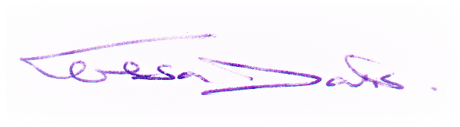

**Public questions during a remote meeting:** Questions can be forwarded to the Clerk prior to the meeting via email (as above) or given in person during item 3 - Public Participation. Members of the public may not take part in the Parish Council meeting itself, unless with the permission of the Chairman to do so..

**AGENDA**

1. **Meeting administration**
2. To open the meeting and welcome everyone
3. To advise on the completion of Register of Interests
4. To consider & Approve Apologies for absence
5. To receive Declarations of interest on agenda items
6. **To Approve the draft minutes of the Annual Parish Council Meeting held on 28th May 2024 and for the Chairman to sign as a true record**
7. Matters arising from the minutes
8. **Public Participation Session** (To hear reports from the County Councillor, District Councillor and Comments from the Public)
9. **Chair Report**
10. **Clerk Report, with details of emails and correspondence up to the period 24th June 2024**
11. **Standing Items agreed from the Parish Plan EGM**

**i. Road Erosion - Cty Cllr Oakes**

**ii. The Flood Plan - Cllr Seddon**

**iii. Overhanging Vegetation on roads - to discuss SCC Community Self Help**

1. **Planning & Governance Consultations - None**
2. **To consider and approve the suggested NALC Data Protection Policy & SALC Template**
3. **To discuss and approve councillor emails and potential cost for the provision of 2 additional emails**
4. **Finance**
5. **Current Bank Balances as at 31st May 2024:-**

**Current Account = £4,362.00**

**Savings Account = £14,466.04**

1. **To Review and Authorise payments:-**

**i. Viking Office Supplies (High Vis Jackets & Long Handled Litter Pickers) £263.88**

**ii. Clerk Wages £396.15**

**iii. MSDC Annual Bin emptying £268.97**

**c) To discuss and confirm new Councillor banking viewing and authorisation**

1. **Next Meeting scheduled for Monday 2nd Sept 2024**