**Offton and Willisham Parish Council**

Clerk to the Council: Miss T Davis

16 Bramley Place, Debenham

STOWMARKET

IP14 6FG

Tel: 07425 672631

[Clerk@offtonandwillisham-pc.gov.uk](mailto:Clerk@offtonandwillisham-pc.gov.uk)

**14th February 2025**

I hereby give notice that the meeting of Offton & Willisham Parish Council will be held at the Offton and Willisham Village Hall on Thursday 20th February 2025 commencing at 7.00pm. The Press and the Public are invited to attend, Councillors are summoned to attend.

The Parish Council, members of the public and the press may record, film, photograph or broadcast this meeting when the public and the press are not lawfully excluded. Any member of the public who attends a meeting and wishes to record, film, and photograph or broadcast the meeting should advise the Parish Clerk.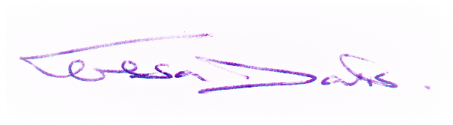

**Public questions during a meeting:** Questions can be forwarded to the Clerk prior to the meeting via email (as above) or given in person during item 3 - Public Participation. Members of the public may not take part in the Parish Council meeting itself, unless with the permission of the Chairman to do so.

**AGENDA**

1. **Meeting administration**
2. To open the meeting and welcome everyone
3. To consider & Approve Apologies for absence
4. To receive Declarations of interest on agenda items
5. **To Approve the draft minutes of the Parish Council Meeting held on 7th January 2025 and for the Chairman to sign as a true record**
6. Matters arising from the minutes
7. **Public Participation Session** (To hear reports from the County Councillor, District Councillor and Comments from the Public and invited guest speakers)
8. **NSIP Planning Consultation from National Grid - Norwich to Tilbury, Closing date 3rd March 2025**
9. **Next meeting currently scheduled for 4th March 2025**